COSC 385 – Theory of Formal Languages, Grammars, and Automata

Spring 2024

Project 3

Problem S-T

Warren Shakes

Function

My function, named is_preorder_relation has two variables named reflexive and transition.   
  
First we have the reflexive variable. It does this by iterating over the elements of the set of y values in the relation. For each element x, it checks if the tuple (x,x) is present in R, indicating that x is related to itself.The result of this check is stored in the variable reflexive

Next we have the transitive variable. It checks if R is transitive by iterating over all possible combinations of elements in the relation. For each tuple (a,b) and (b,c) in R, it checks if the tuple (a,c) is also present in R, indicating that the relation is transitive.

Finally, the function returns True if both reflexive and transitive are True, indicating that R satisfies both reflexivity and transitivity and thus is a preorder relation. Otherwise the function returns false.

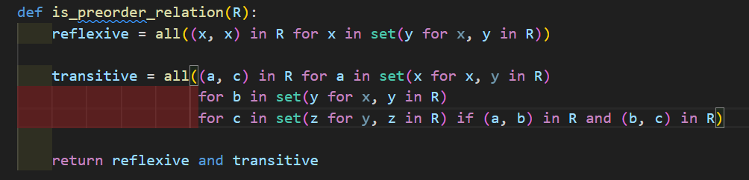

Program

My program takes in a set of tuples and prints whether they are true or false.

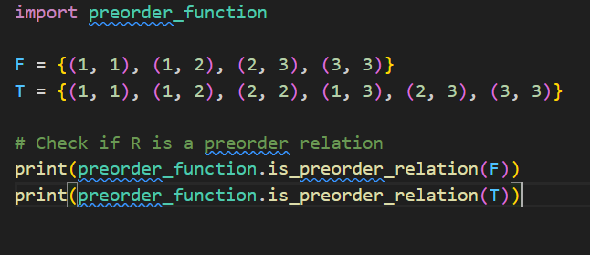

Examples

